**Tasks : 10/27/2017 Due 6.00 PM CST on 10/27/2017**

**AWS :**

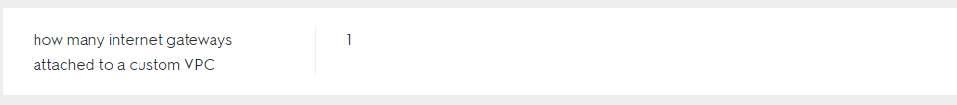

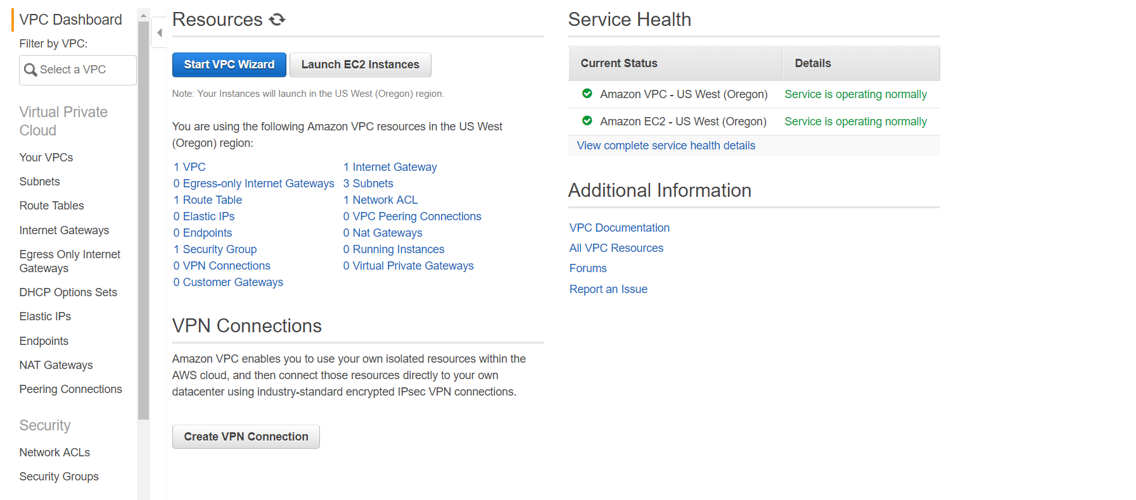

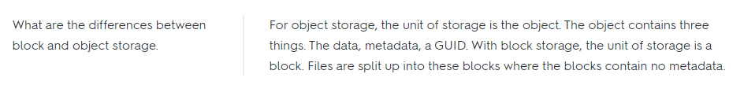

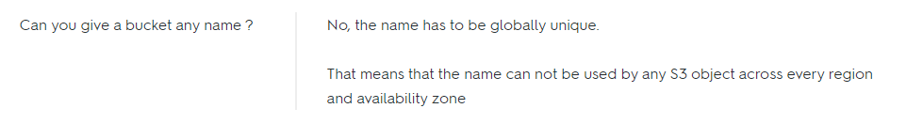





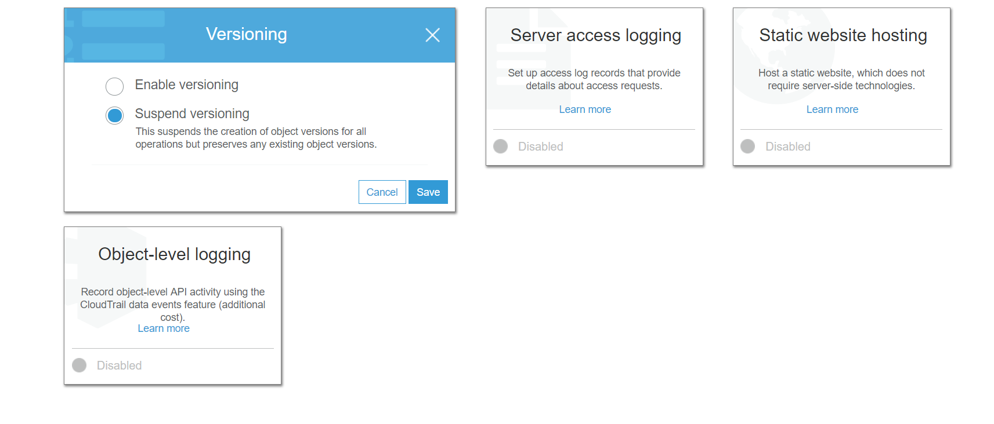

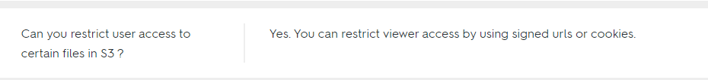

**Spring**

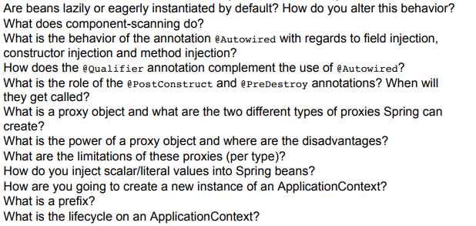

**Java 8**

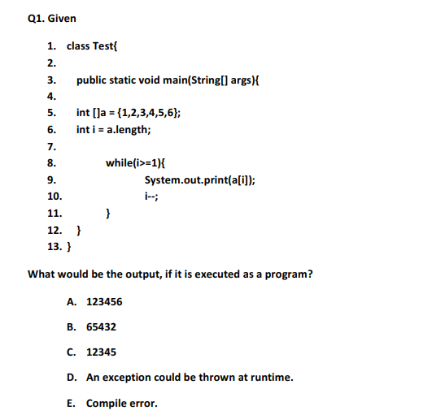

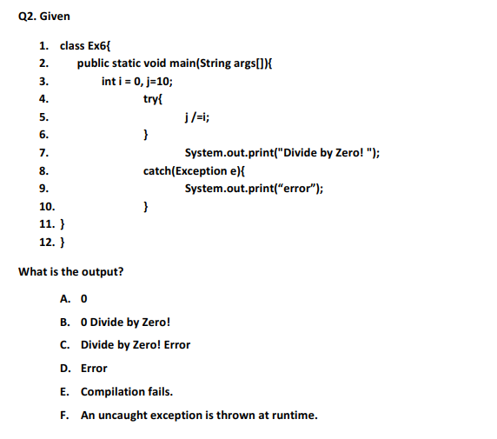



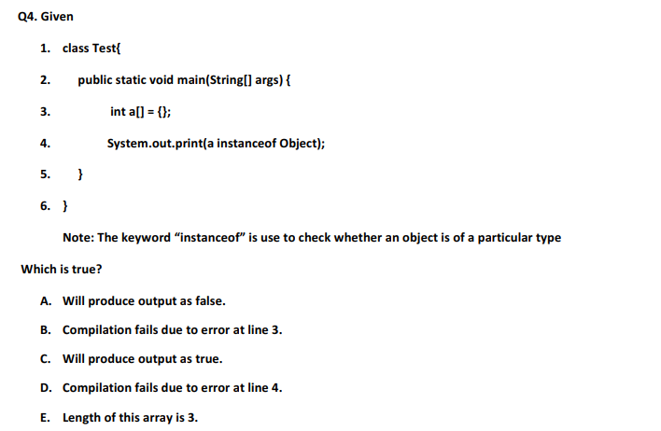

**Angular 4**

**Integrate Angular 4 with Spring Boot WebApp and SpringToolSuite**

**Database**

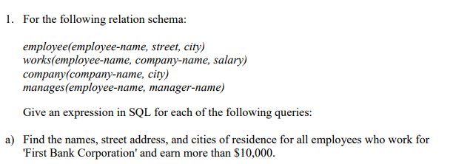

**select e.employeeName, e.street, e.city from**

**employee e, works w where e.employeeName=w.employeeName and (companyName = 'First Bank Corporation' and salary > 10000);**

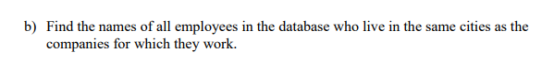

**select e.employeeName from employee e, company c, works w where e.city=c.city and w.companyName=c.companyName and w.employeeName=e.employeeName;**

